Digital Video Surveillance Center Management Software
NVClient

User Manual

Revision: V3.2
Updated On: 2011-1-17
Preface

We very appreciate your selection of the digital surveillance center management software developed by our company. Please carefully read this manual before using this software. If you come across a problem during operation and can’t solve it as instructed in the manual, please contact the technical support center of our company or your distributor.

This manual is subject to nonscheduled update without notice.

Contents
Chapter I General - 4 -
1.1 Introduction - 4 -
1.2 Main Functions - 4 -
Chapter II Software Operating Environment Requirements - 5 -
2.1 Operating System - 5 -
2.2 Minimum Configuration of Hardware Environment - 5 -
2.3 Recommended Configuration of Hardware Environment - 5 -
2.4 Software Environment Configuration - 5 -
Chapter III Software Installation and Uninstallation - 5 -
3.1 Software Acquirement - 5 -
3.2 Software Installation - 6 -
3.3 Software Deletion - 6 -
3.4 Software Logon - 7 -
Chapter IV Introduction to Main Interface - 9 -
4.1 System Setup Area - 9 -
4.2 Device Management List Area - 10 -
4.8 Cradle Head Control Area - 12 -
4.9 Date Display Area - 12 -
4.10 Image Display Window Area - 12 -
Chapter V: Details for Function Settings - 13 -
5.1 System Setup Area - 13 -
5.3 Talkback Setup - 36 -
5.4 Cradle Head Control Setup - 37 -
5.5 Image Display Window Area Setup - 39 -
Chapter VI Common Problems in Center Management Software - 41 -
6.1 Unable to access the network surveillance device via the center management software - 41 -
6.2 Abnormal image color - 41 -
6.3 Cradle head and lens out of control - 41 -
6.4 No sound when listening - 42 -
6.5 Bad audio effect - 42 -
Chapter VII Factors Influencing System Performance - 43 -

Chapter I General

1.1 Introduction
This digital surveillance center management software (hereinafter referred to as Center Management Software) conducts centralized monitoring, storage, management and control of all front-end network video surveillance devices (including network video server, network camera and video decoder) and network digital video recorder. This center management software can simultaneously display up to 36 audio and video images, and it can also conduct setup, control and remote upgrade of any device.
This center management software supports the switch between 1/4/9/16/25/36 images, two-way voice intercom, E-map, log retrieval, alarm control, remote retrieval playback. Powerful function, friendly interface and easy operation of this software make the user easily achieve the networking of small and medium remote network surveillance system.

1.2 Main Functions
The main functions of this center management software include:
- Simultaneously display up to 36 ways of audio and video channels
- Centralized monitoring, storage, data transmission, management and control of all front-end network video surveillance devices, including network video server, network camera and network DVR
- Support decoded output of 16-way video wall
- Display e-map
- Real-time image monitoring preview
- Two-way voice intercom and voice broadcast
- Video recording (pre-video recording, manual video recording, alarm linkage video recording and time video recording)
- Provide retrieval and playback of video records of different channels and dates
- Cradle head control, presetting, call and cradle head cruise
- Support packet switch display and auto patrol display
- Support preset position call of alarm linkage
- Support front-end probe triggered alarm of video loss, video movement and network abnormal interruption
- Log Management
- Back-end snapshot and front-end snapshot
- Support reverse connection
- DDNS(Dynamic Domain Name System)
- PPPOE (Dial-up Internet Service)
- Support data transparent transmission

Chapter II Software Operating Environment Requirements

2.1 Operating System
32-bit/64-bit Simplified Chinese/English Windows 2000, Windows 2003, Windows XP/Vista and Windows 7

2.2 Minimum Configuration of Hardware Environment
CPU: Pentium 2.0Ghz
Memory: 256 MB
Display Card: TNT2
Sound Card: Necessary for voice monitoring and two-way intercom
40G Hard Disk: Shall be not less than 40G if the video recording is necessary

2.3 Recommended Configuration of Hardware Environment
CPU: Intel Core2 Duo E7400 2.8G
Memory: 2G
Display Card: NVIDIA GeForce 9600GSO
Hard Disk: SATA Hard Disk, 8M or above cache memory, 2000G

2.4 Software Environment Configuration
IE 6.0 or above
DirectX9.0 or above
TCP／IP Internet Protocol

Chapter III Software Installation and Uninstallation

3.1 Software Acquirement
Method 1: Place the CD supplied with the network camera or network video server in the CD-ROM driver and find the installation file of center management software and then copy the installation file to your personal computer. Double click the installation file to start setup. After completion of installation of this software, you can find the NVClient software under 『“Digital Video Management Center” under “All Programs” under “Start” 』menu, and you can directly double click the “NVClient” to run the main program.
Method 2: You can also contact our technical support department to acquire the center management software via remote transmission by QQ, MSN and Email.
Method 3: Access our official website and enter the downloading center to download this software.

3.2 Software Installation
Select and double click the installation program file of the center management software. The dialog box as below will appear.
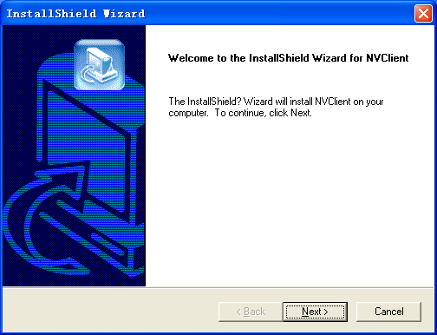
Figure (1)
Click 『Next』 following the prompt until the 『Finish』 button appears.
Click the『Finish』button to 『Finish』 installation.

3.3 Software Deletion
There are two methods to delete the center management software:
- In the Start menu, select “Programs” → “Digital Video Management Center” → “Uninstall” to conduction the uninstallation of this software.
- Open the “Add or Remove Programs” of “Control Panel”, and then select the “NVClient” option in the program list to delete it.
The dialogue box of deletion is as below:
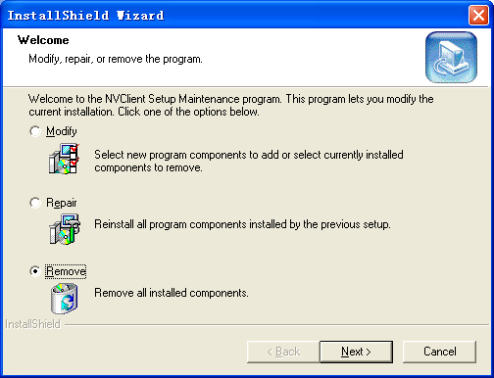
Figure (2)

3.4 Software Logon
When you run this software for the first time, the dialog box as below will appear. You need to firstly register a user for administrator (The password must be at least 6 digits long).
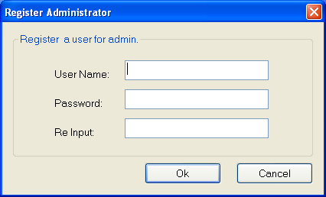
Figure (3)
And later when you double click the center management software icon 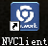, the login dialog box of center management software as below will pop up.
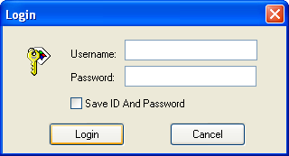
Figure (4)
『User Name』: Input the registered user name.
『Password』: Input the registered password.
『Remember Password』: When this box is checked, the system will automatically login the center management software screen when you enter this management software next time.

Chapter IV Introduction to Main Interface
A single screen of main interface of this center management software can display up to 64 ways of images, and you can manually switch between screens as required or set the automatic switching to patrol all connected channels.
Image Display Window Area & Status
System Setup Area
About, Min and Close Button

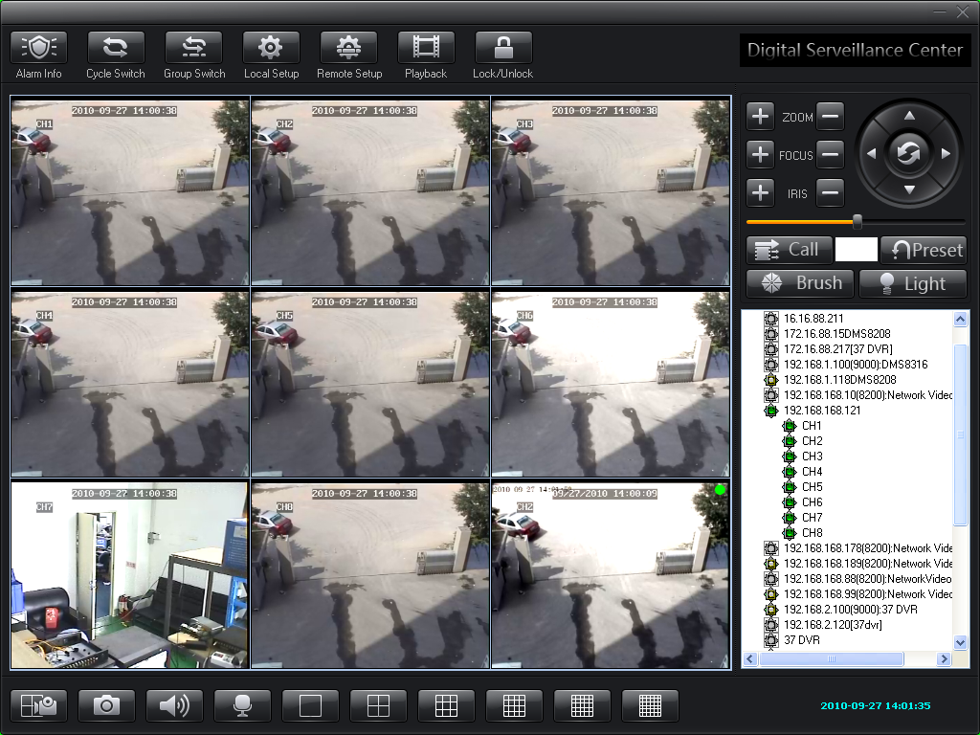
Cradle Head Control Area
Device Management List Area
Channel Status
Sound Switch
Figure (5)
Screen Display Switch
Snapshot
Date Display
Audio Interaction

4.1 System Setup Area
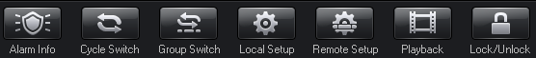
Figure (6)
This area includes the following options:
『Alarm Info』Click this button to view the detailed information of video alarm
『Cyclic Switch』Click this button to enter the screen cyclic switching status
『Video Switch On Group』Click this button to manually conduct the video switch on group.
For detailed settings, please see the section Video Switch On Group of Chapter V.
『Local Setup』This item totally includes『General Settings』, 『Local Image View』, 『Group Switch』, 『Time Video Recording Settings』, 『Services』, 『Log View』, 『Advanced Settings』, 『Digital Matrix』 and 『Virtual Matrix』
For detailed information, please the section Local Setup of Chapter V.
『Remote Setup』This item is mainly intended for the settings of front-end video encoder and decoder
『Playback』Support online playback of the video recording files
For detailed information, please the section File Playback Setup of Chapter V.
『Lock/Unlock』After this button is clicked, the system will enter into a status where the user is required to input the User Name and Password and he can not operate any function. The user can only normally operation this center management software after the system is unlocked.

4.2 Device Management List Area
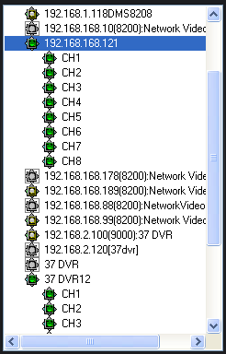
Figure (7)
This area is used for centralized management and control of front-end video encoding and decoding devices.
For details, please see the section Device Management List Area Setup of Chapter V.
4.3 Channel Status Area
Click this button to display the status information of the video codec connected to this center management software. For details, please see the figure below.
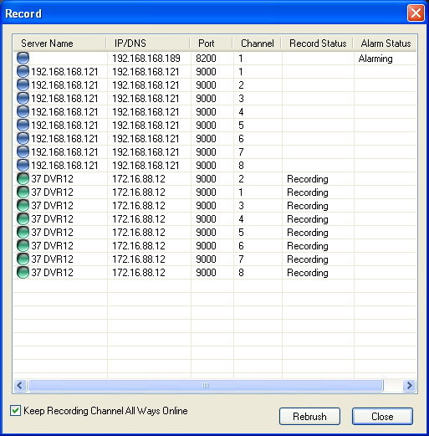
Figure (8)
4.4 Snapshot Area
Click this button to shoot the selected image. The shot image will be saved in the specified directory of the computer.
4.5 Sound Switch Area
There are two statuses in total: On and Off.
4.6 Audio Interaction Area
Click this button to set the voice intercom function.
For details, please see the section Voice Intercom Setup of Chapter V.
4.7 Screen Display Switch
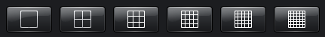
Figure (9)
Yon can select to switch between 1/4/9/16/25/36 screens in this area (If you want to display other screens than the options mentioned hereinabove, please right click the preview screen, and then select 【Screen Display】 to display 6, 10, 24, 49 and 64 screens).

4.8 Cradle Head Control Area
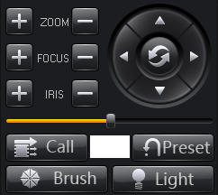
Figure (10)
Function Description: This area is mainly intended for control of front-end cradle head, such as cradle head movement, preset position setup, focus, zoom, iris, wiper and auxiliary lighting.
For details, please see the section Cradle Head Control Setup of Chapter V.

4.9 Date Display Area
This area displays the current time and date of the system.


4.10 Image Display Window Area
Function Description: Real-time display of front-end video images and client settings.
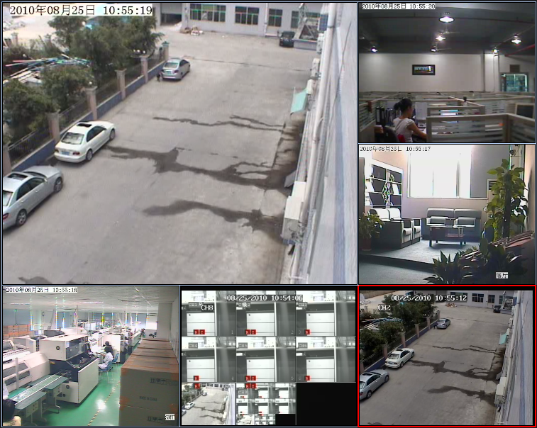
Figure (11)
For details, please see the section Image Display Window Area Setup of Chapter V.

Chapter V: Details for Function Settings

5.1 System Setup Area
This item includes the function modules 『Alarm Info』, 『Cyclic Switch』, 『Group Switch』, 『Local Setup』, 『Remote Setup』, 『Playback』 and 『Lock/Unlock』.

5.1.1 Local Setup
This item includes 『Common Setup』, 『Local Picture View』, 『Video Switch On Group』, 『On Time Record』, 『Service』, 『Local Log View』, 『Stream Matrix』 and 『Virtual Matrix』.

5.1.1.1 Common Setup
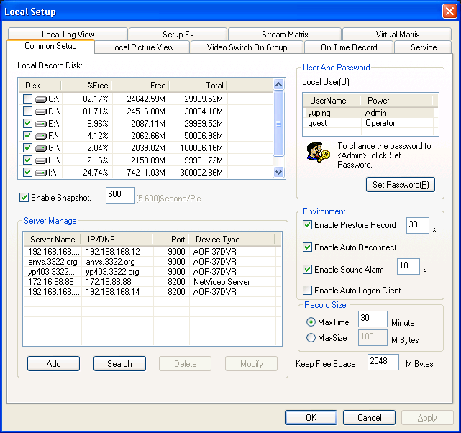
Figure (12)
This item is mainly intended for the configuration of 『Local Record Disk』, 『User and Password』, 『Record Size』, 『Environment』 and 『Server Manage』

5.1.1.1.1 Local Record Disk
Function Description: Set the saving path of video recording files. Under this option, the total space and free space available of the disk can be displayed visually. This way the user can easily select the path to save the images according to the actual situation.
For example: If you want to save the video recording files in the Disk C, please proceed with the following procedures.
Check the disk C, and the system will automatically create a folder NVFile under the root directory of disk C. All video recording files and shot images of this center management software will be saved in this directory.

5.1.1.1.2 User and Password
Function Description: Set the user name and password for login of this center management software
When you login the center management software for the first time, you must firstly create a user for administrator. After the user successfully logs in this software, he/she can modify his/her user name and password. The modification steps are as below:
Step 1: Click『Administrator/Operator』
Step 2: Click『Set Password』, and the dialogue box below will pop up.
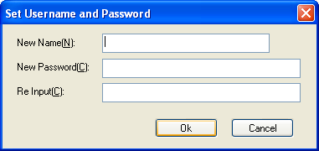
Figure (13)
Step 3: Input your new user name, new password and confirmed password after the boxes 『New User Name』, 『New Password』 and 『Re-input』 and then click『OK』 to save the settings.

5.1.1.1.3 Record Size
The user can set the record size as required. There are two recording methods:
- Per Duration Length: The minimum record duration is 1 minute, and the maximum record duration is 720 minutes
- Per File Size: The minimum file size is 1M, and the maximum file size is 2048M

5.1.1.1.4 Server Manage
Function Description: The client software can only search for the video devices in the local area network. Therefore if the user needs to conduct the centralized management of remote devices, he/she needs to manually add the server. The steps to add the server are as below:
Click the 『Add』button, and the dialogue box below will pop up.
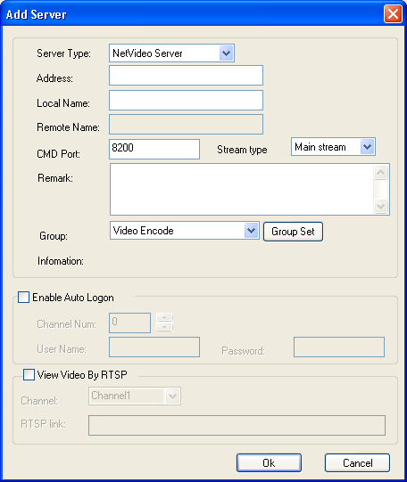
Figure (14)
Step 1: Click the Server Type drop-down list box, and then select the device type to be added.
Step 2: Input the address of device (IP address or domain name) after the Address box.
Step 3: Input the use defined local name after the Local Name box.
Step 4: Input the data port number of the device after the CMD Port box. The default port number for DVS/IP Camera/37 series network DVR is 8200, this port is user definable. You can fill this box using the data port number in the networking settings.
Check the box 『Enable Auto Logon』. When you logon the server next time, it is not necessary to input user name and password.
In the local area network, the steps to add the DVS/IP Camera/37 series network DVR server are as below:
Click the 『Search』button, and the dialogue box below will pop up.

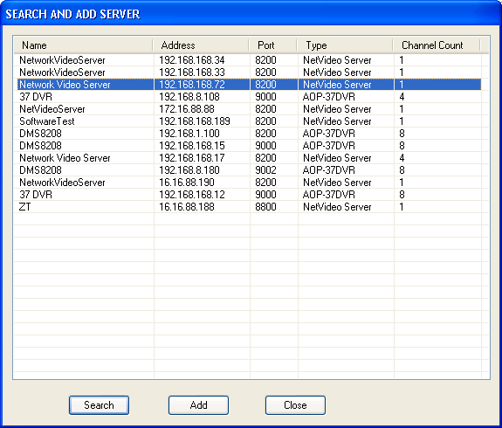
Figure (15)
Step 1: Select the device which you want to add in the search box.
Step 2: Click the 『Add』button, and the dialogue box below will pop up.

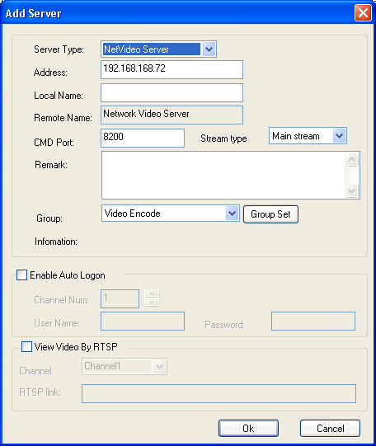
图（16）
Step 3: Input the use defined local name after the Local Name box.
Check the box 『Enable Auto Logon』. When you logon the server next time, it is not necessary to input user name and password.

5.1.1.1.5 Environment
- 『Enable Pre-store Record』 When you select this function, the system will pre-store the videos for 5 – 60 seconds before alarm when the system start the alarm linkage video recording.
- 『Enable Auto Reconnect』When you select this function, the system will automatically reconnect to the front-end video server when the network recovers to the normal status in case of font-end device disconnection.
- 『Enable Sound Alarm』 When you select this function, PC will give off the alarm sound to prompt the user when there is an front-end alarm output.
- 『Enable Auto Logon Client』When you select this function, it will not prompt you to input the user name and password any more when you logon the system next time.

5.1.1.2 Local Picture View
This function is used to view the surveillance pictures saved in the local system. Please see the below screen:
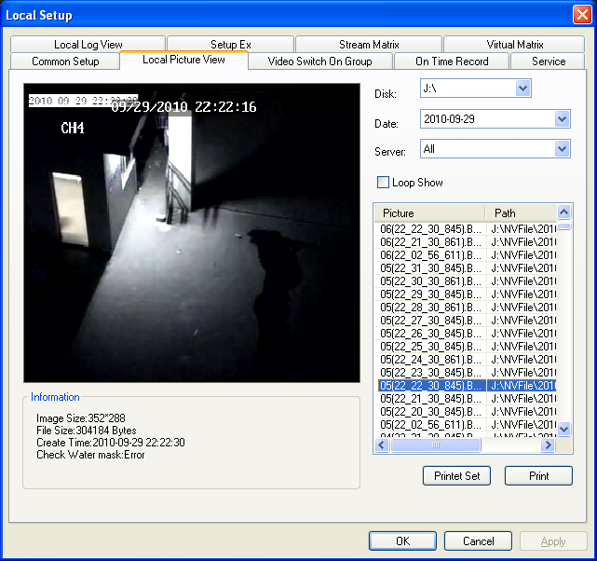
Figure (17)
『Disk』Search for the picture file by the position where the picture is saved.
『Date』Search for the picture file by the date.
『Server』Search for the picture file by the video server name.
『Loop Show』Preview the searched picture files in loop.
『Print』Print out the selected picture file.

5.1.1.3 Video Switch On Group
The user can set many groups as required, and display the videos by group or in circle.
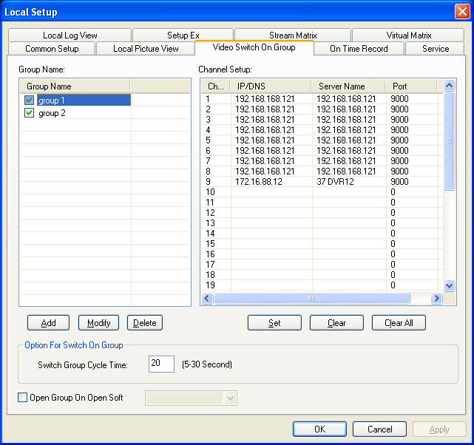
Figure (18)
The setting steps for video switch on group are as below:
Note: The video switch on group can only be conducted when you automatically logon the server.

Solution 1: Set the group in the Video Switch On Group setting box (take the setting of Group 1 as an example)
Step 1: Set the video server to automatically logon this software.
In the software screen, select the video server, and then right click the mouse, and then select the 『Properties』.The dialogue box 『Change Server Parameters』will pop up.
Check the box Enable Auto Logon, and then input the correct user name and password after the『User Name』and 『Password』boxes, and then click 『OK』，to save the settings. For details, please see the below screen:
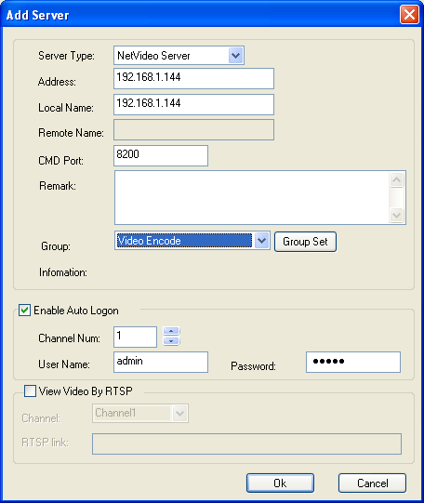
Figure (19)
Step 2: Add a group
Click the『Add』button on the screen above to add the group name
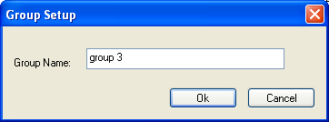
Figure (20)
Step 3: Allocate the video server to a group
Select the group and click the Setup button to add the video server that is needed to allocate to the group. Up to 36 video channels can be allocated to a group, and up to 36 groups can be added.
Step 4: In the 『Option for Switch On Group』, set the switch group cycle time between groups. The minimum switch interval is 5S and the maximum switch interval is 120S.
Step 5: Select 『Apply』, 『OK』to save the settings.

Solution 2: Quick setting of group (take the setting of Group 1 as an example)
Step 1: Set the video server to automatically logon this software.
Step 2: Open the channel to be allocated to the group in the Video Window Area.
Step 3: Right click the mouse and then select 『Save Current Channel As』.
Step 4: Input the user defined group name, for example “Group 1”.
Step 5: Click 『OK』 to save the settings.

5.1.1.4 On Time Record
Remark: The setting for on time record can only be conducted when the network video encoder automatically logon the server.
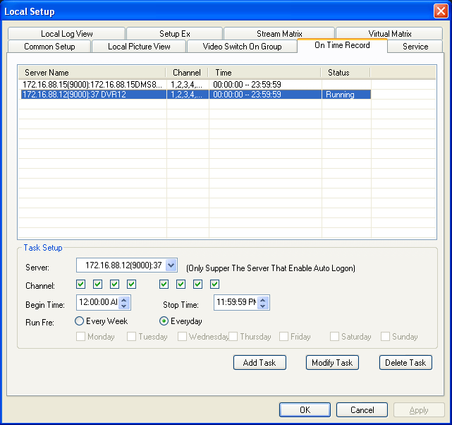
Figure (21)
The setting steps for on time record are as below:
Step 1: Set the video server to automatically logon this software.
Step 2: Select 『Server』, select the server for which you need to make on time record in the drop-down menu.
Step 3: Select the『Channel』(make selection according to the number of channels of the device) for which the server needs to make on time video.
Step 4: Set『Begin Time』 and 『Stop Time』of on time record.
Step 5: Set『Run Fre』of on time record:『Every Week』 and 『Every Day』.
Step 6: Click the『Add Task』button, and then click 『Apply』 and 『OK』to save the settings.

5.1.1.5 Service
Function Description
This item is intended for settings of alarm linkage, alarm sound and hardware decode.
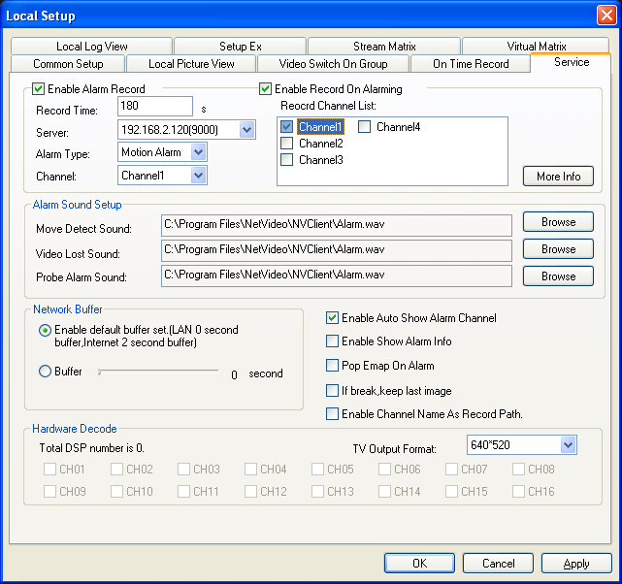
Figure (22)

5.1.1.5.1 Alarm Linkage
Enable Alarm Linkage refers to selecting the video server to make the video recording when there is a font-end alarm event.
The settings are made as below:
Step 1: Check the box 『Enable Alarm Record』. When the system sets the alarm status, the sub-option can record the video occurring when the alarm is present. The record time can be set between 30 and 600 seconds.
Step 2: Check the box 『Enable Alarm Linkage』.
Step 2: In the 『Server』option, select the server to make alarm linkage.
Step 3: In the 『Alarm Type』option, select the alarm type.
There are three alarm types available:『Move Detect』, 『Probe Alarm』 and 『Video Lost』.
Step 4: Check the box 『Enable Record On Alarming』 (Channel 1 - 4 available)
Step 5: Click the 『Apply』 and 『OK』to save the parameters.

5.1.1.5.2 Alarm Sound Setup
The user can set the Move Detect Sound, Video Lost Sound and Probe Alarm Sound as required.
Note: The sound file must be of wav format.

5.1.1.5.4 Auto Channel Popup for Alarm
When this item is checked and the server is in the logon status, the center management software will automatically open the alarm channel and maximize the screen when there is an alarm.
5.1.1.5.5 Hardware Decode
When you build the TV wall using the decoding card, it will display the status of DSP channel.
For detailed settings, please refer to User Manual for Video Encoding Card.
『TV Output Format』It can configure different resolutions according to the actual situation appearing on the monitor.
There are two resolutions available:『640*520』 and 『704*576』.

5.1.1.6 Local Log View
This item is used to view the system log file, and makes the user easily manage and use the system. For details, please see the screen below:
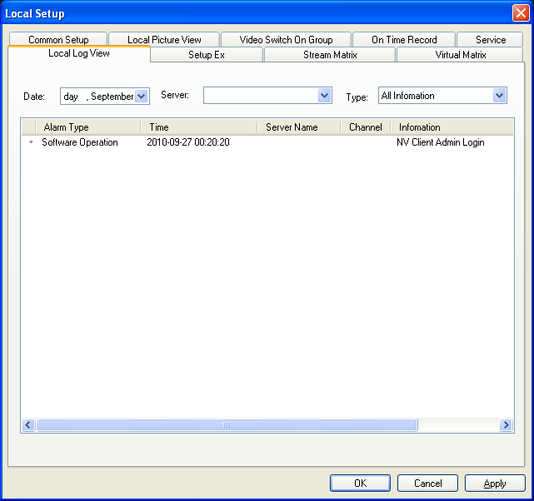
Figure (23)
The settings are made as below:
Step 1: Click the Date drop-down list to select the date that the log is need to be viewed.
Step 2: Select the log display type.
There are two types:『By Server』 and 『By Type』.
Step 3: View the log.
Step 4: Click 『OK』to exit the log view.

5.1.1.7 Setup Ex
Remark
This item is mainly used for enabling local serial port transparent transmission function and automatic logon server function.
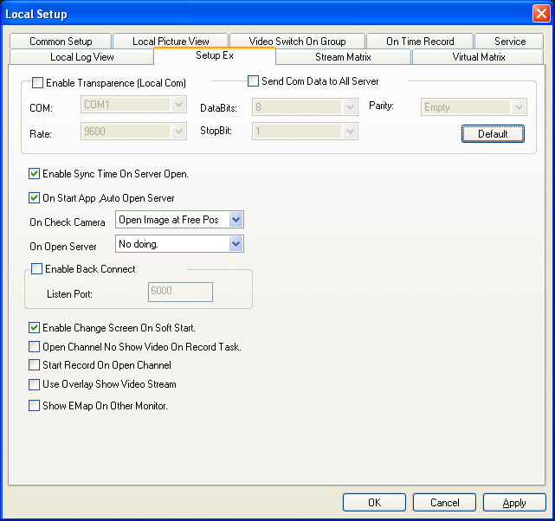
Figure (24)

5.1.1.7.1 Enable Transparence (Local Com) and Send Com Data to All Server
Function Description: When the “Enable Transparence (Local Com)” function is enabled, the date collected on the spot can be transmitted to the serial port of the computer in the surveillance center via 485 interface (or 232 interface) of the video server. For example, the video server is configured in the factory and you want to transmit the data such as voltage to the surveillance center via video server. At this time the local serial port can receive the data from the control port of the video server. When the “Send Com Data to All Server” function is enabled, you can connect the keyboard to the serial port of the computer via “485 to 232 converter” to conduct the direct control of cradle head device connected to the video server or cradle head of the network camera.
It is necessary to match the parameters of serial port devices connected to this computer. The items to be set are 『Com』, 『Data Bits』, 『Parity』, 『Rate』 and 『Stop Bit』.

5.1.1.7.2 Enable Sync Time On Server Open
This item can synchronize the time of front-end video server with that of this computer. The update period is one hour.

5.1.1.7.3 On Start App Auto Open Server
If you select this item, it will automatically logon the video server and video encoder that are preset to be logoned automatically when the center management software is opened. (For those servers that are not preset to be logoned automatically, the center management software will try to logon them using the default user name and password “admin”.

5.1.1.7.4 Enable Back Connect
Function Description: This function is used to mirror remote online video server, and logon the remote video server via client.
Characteristics: With this function, the remote video server will voluntarily report the video data to the client and make connection with the client. Therefore the user can connect the remote video server without troublesome settings such as port mapping.

5.1.1.7.5 Enable Change Screen On Software Start
Function Description: When the client does not support the resolution of your display, if you enable this function, the center management software will automatically modify the resolution of the display to make the software display in full screen.

5.1.1.7.6 Open Channel No Show Video On Record Task
Function Description: When your computer has a relatively lower configuration, the occupation rate of system resource will be high when you open many images at the same time. Therefore you can consider enabling this function to reduce the occupation rate of system resource when you set multiple channels on time record, this way real time video recording can be conducted without image preview.

5.1.1.7.7 Start Record On Open Channel
Function Description: After you logon the video server, once you open a video channel, it will start recording without need to set other parameters.

5.1.1.7.8 Video Encoding Method Setup
When your computer has a relatively lower configuration, please don’t check the box『Use Overlay Show Video Stream』when the display card does not start the hardware acceleration.

Back Connect Settings:
Client Settings
Step 1: Map the port 6000 of this computer where the client software is installed to the wide area network.. For details, please see the below screen.
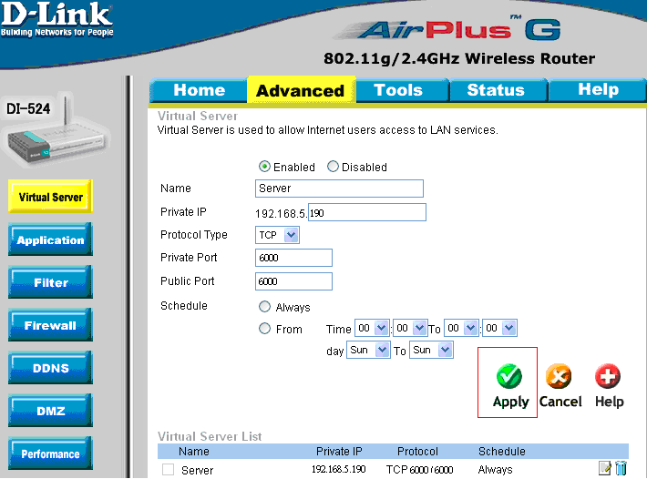
Figure (25)
Step 2: Check the box 『Open local detection, accept remote connection』 as shown in the below screen.
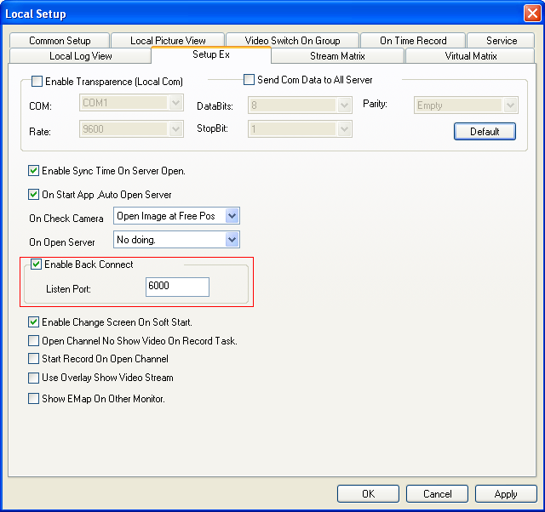
Figure (26)
Network Video Server Settings
Step 1: Log on the network video server, open the Network Setup option, and then check the box『Enable Back Connect』.
In the box Object Host, input IP address of the client for back connection as shown in the below screen:
Port: Input the listen port of client (for example 6000).
Time: It refers to the interval that the video server reports the back connection. It is recommended to set the interval between 3 and 10 seconds.
Step 2: Click 『Set』 to save the parameters.

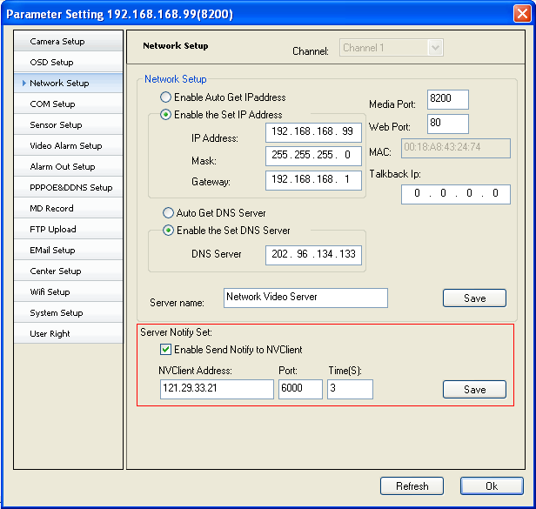
Figure (27)

5.1.1.8 Stream Matrix
Function Description:
The stream matrix is composed of the video decoders. Each video decoder matches a channel of surveillance center.
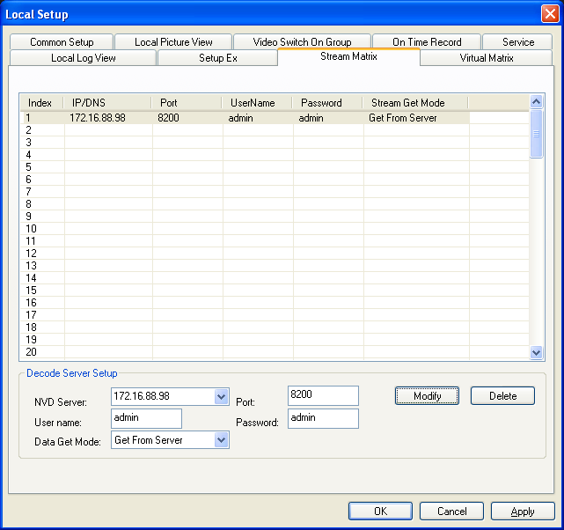
Figure (28)
The steps for stream matrix settings are as below:
Step 1: Connect to the video decoder (For detailed operation, please refer to the User Manual for Decoder))
Step 2: Click the indexes. There are indexes 1 – 96 available.
Step 3: According to your requirement, select the decoder from the『NVD Server』 drop-down menu, and then input the『Port』, 『User Name』 and 『Password』 of decoder.
Step 4: Select the data get mode: Direct Connect or Center Relay.
Step 5: Click『Modify』, and then select 『Apply』 and 『OK』，to save the settings

5.1.1.9 Virtual Matrix
This item can make the video encoder channel match the video decoder channel.
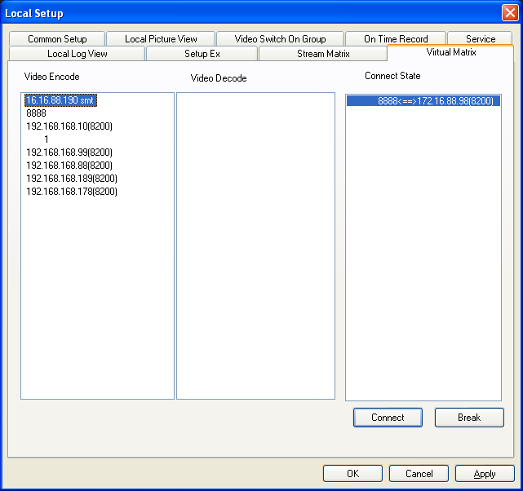
Figure (29)
The setting steps are as below:
Step 1: Double click the desired 『Video Encode』, and then select the desired encoder channel.
Step 2: Double click the desired 『Video Decode』, and then select the desired decoder channel.
Step 3: Click 『Connect』.
Step 4: Click 『OK』to save the settings.

5.1.2 Remote Setup
The Remote Setup is mainly used to configure different function parameters of front-end video encoder.
For detailed configuration, please refer to the User Manual for Encoder and User Manual for Decoder.

5.1.3 Playback
Function Description: This item can playback the video recording files, and supports simultaneous playback of 4 channels and retrieval of video records.
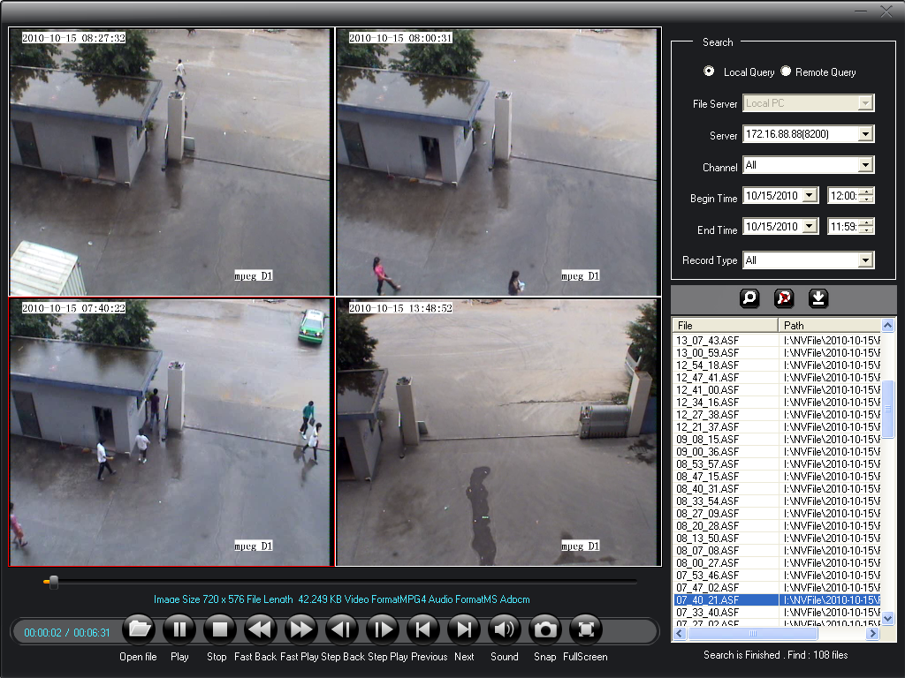
Figure (30)
Function Introduction
『Local Query』Search for the video recording files saved on the local computer disk.
『Remote Query』Search for the video recording files saved on the removable disk.
『Server』Search for the video recording files by the address of font-end encoder.
『Channel』Search for the video recording files by the channel ID of encoder.
『Begin Time』Begin time of record retrieval.
『End Time』End time of record retrieval.
『Record Type』Search for the video recording files by the record type.

5.2 Device Management List Area Setup
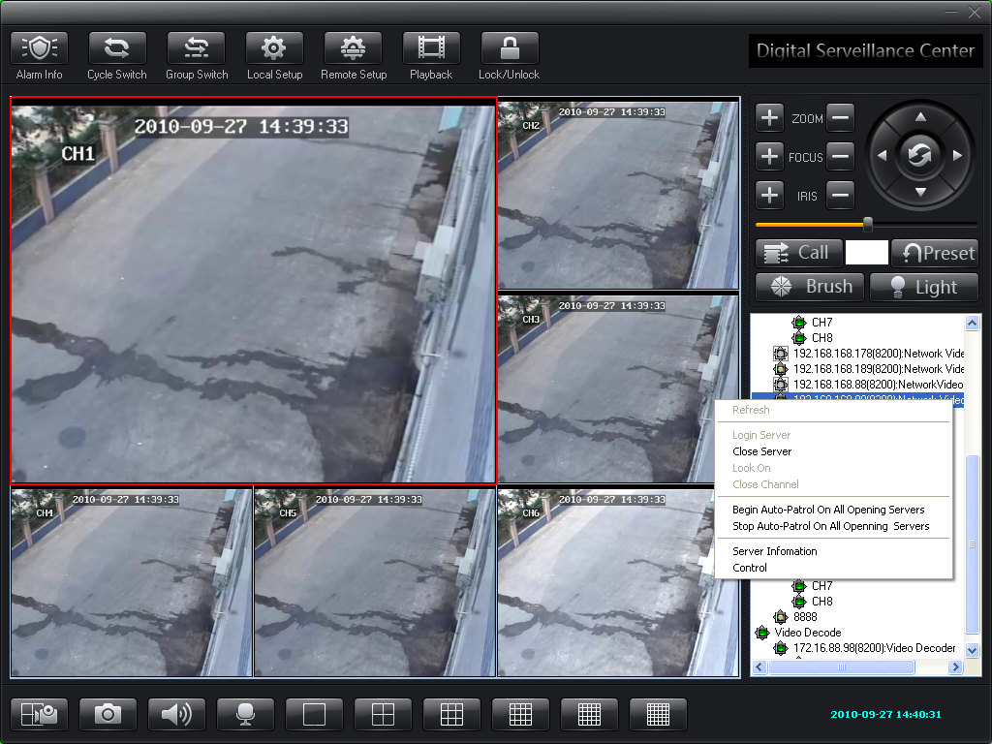
Figure (31)

5.2.1 Logon Video Server
Step 1: Right click the video server name, and the dialogue box below will pop up.

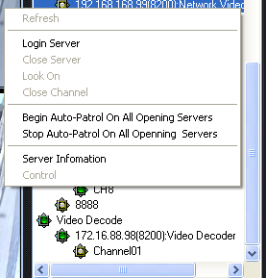
Figure (32)
Step 2: Click『Logon Server』.
Click this item, and then the Logon Server dialogue box will pop up. Please input the correct user name and password to finish logon.

5.2.2 Probe Output Control
You can control the open or close of relay for the front-end devices by group to realize special function.
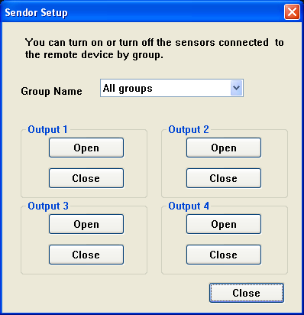
Figure (33)

5.2.3 Probe Output Setup
This item can make the alarm output relay of encoder or decoder in your customized group open or close at the specified time.
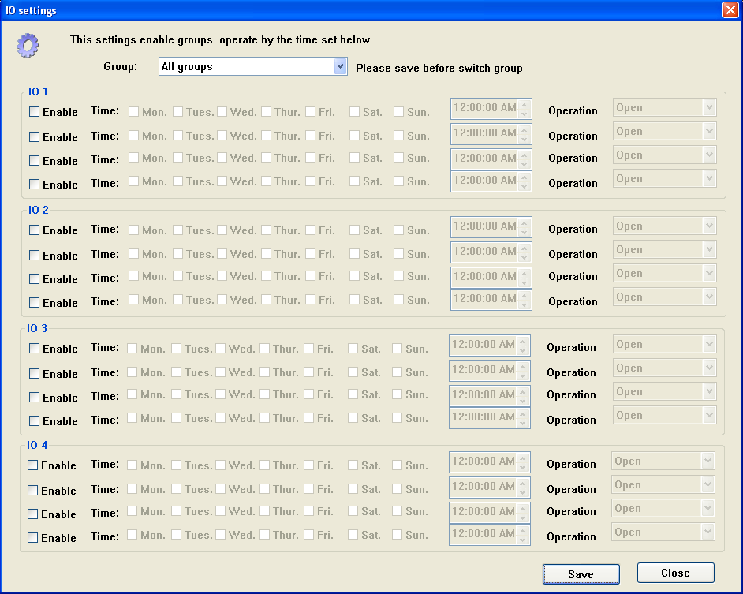
Figure (34)

5.3 Talkback Setup
Function Description: Set the talkback function. It can make the center control terminal communicate with and listen the front-end video server, and can also record the communication contents.
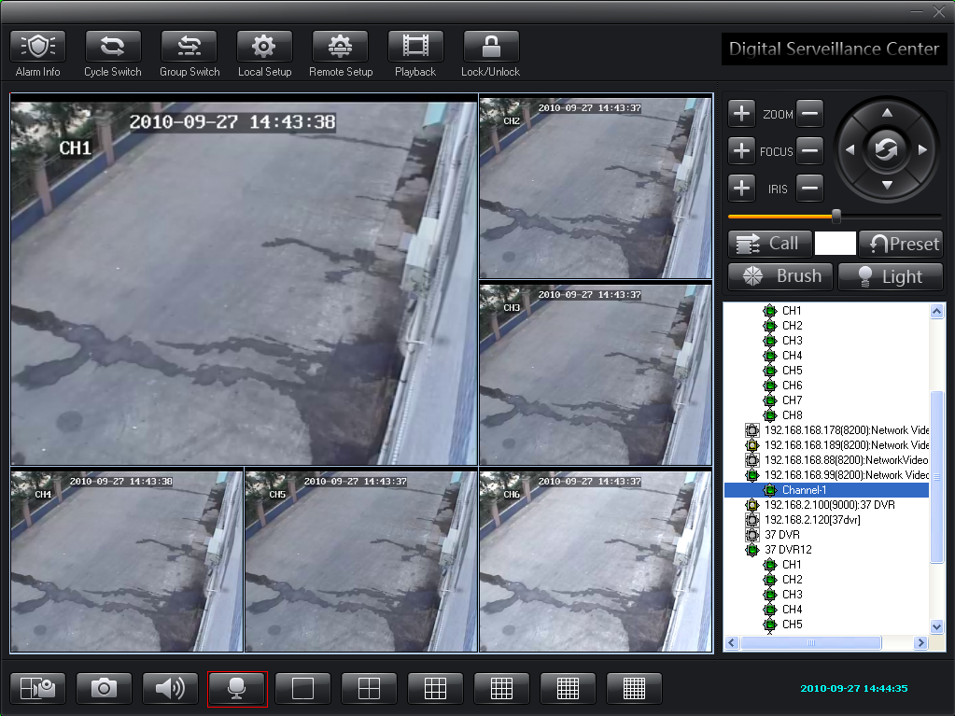
Figure (35)
The steps to set the talkback are as below:
Step 1: Set the video server.
Connect the audio output device as required as shown in the below wiring diagram (take DVS as an example).
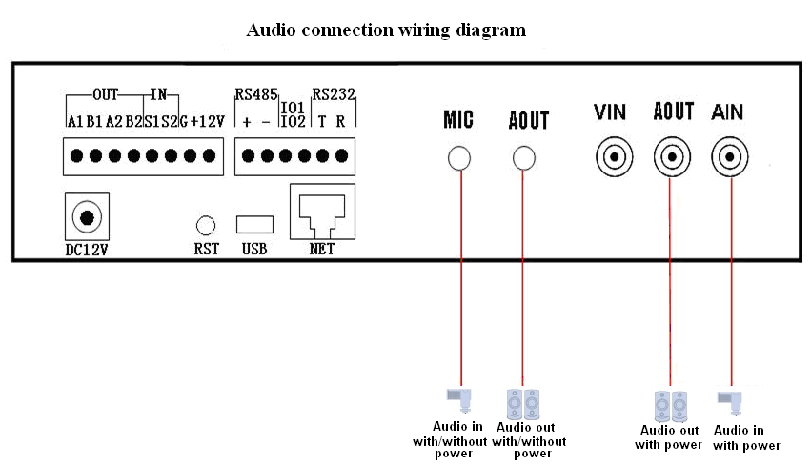
Figure (36)
Step 2: Click the Audio Interaction button, and the Talkback Manager setting box as shown below will pop up.
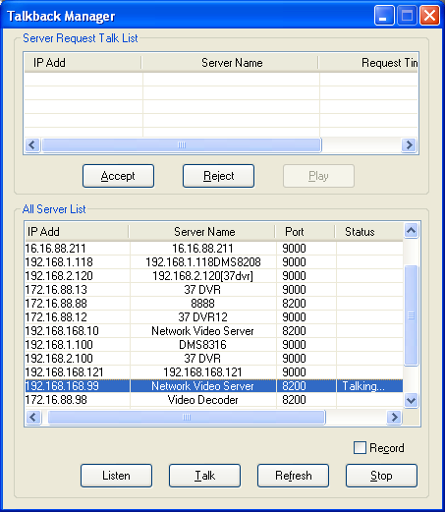
Figure (37)
Step 3: In the 『All Server List』, select the server you need to talk.
Step 4: Click 『Talk』, and the screen will display『Talking』.
Listen:

5.4 Cradle Head Control Setup
Function Description: If you want to control the front-end device corresponding to the selected window, you must firstly set the encoder type corresponding to it. For detailed settings, please refer to the User Manual for Network Video Server.

Figure (38)
Button Introduction
『Call』Selecting this item will make the system return to the preset position quickly and correctly.
『Preset』Set the preset position
『Light』Open or Close the light
『Brush』Open or Close the brush
『Zoom』Adjust the magnification of zoom lens. There are two options as shown in the above picture: Plus (+) and Minus (-)
『Iris』Adjust the amount of light passing through the lens. There are two options as shown in the above picture: Plus (+) and Minus (-).
『Focus』It refers to the course that selects the most clear point. There are two options as shown in the above picture: Plus (+) and Minus (-).
『Cradle Head Direction Key』Click different direction keys to control the UP, Down, Left and Right movement of the cradle head. Please see the picture above for details.
Setup and Call for Cradle Head Preset Position
The preset function is that the dome camera stores the position parameters, such as horizontal angle, vertical angle and lens focus, in it in the form of the numbers (0~255), this way you can quickly call these parameters to adjust the dome camera to the desired position if necessary. The operator can easily store and call the preset position. The dome camera supports 256 preset positions.
Setup for Cradle Head Preset Position (take the setting of preset position “1” as an example)
Step 1: In the 『Settings』box, input the preset number “1” as shown in the picture.
Step 2: Click the『Cradle Head Direction』button. The user moves the cradle head to the preset position according to his/her requirement.
Step 3: Click 『Preset』to save the settings.
Call for Cradle Head Preset Position (take the call of preset position “1” as an example)
Step 1: In the 『Settings』box, input the preset number “1” as shown in the picture.
Step 2: Click the『Call』button to start the call of preset position.
Setup for Cradle Head Cruise
Please refer to Cradle Head Cruise

5.5 Image Display Window Area Setup
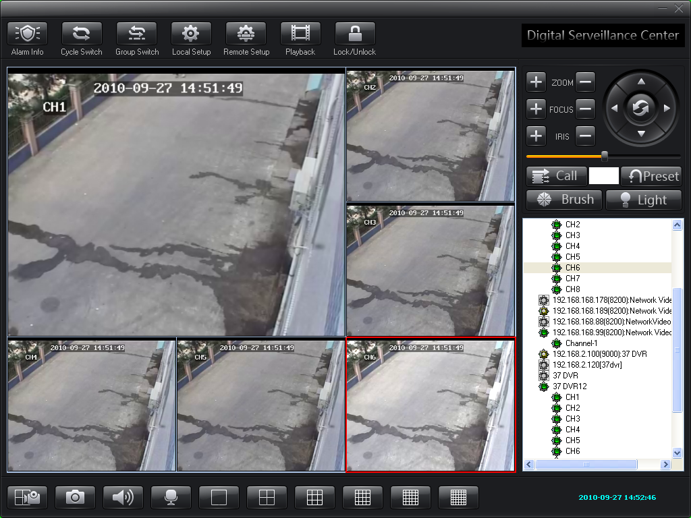
In this area, you can view front-end real-time videos and make system settings. The video display window can switch between 1/4/9/16/25/36 pictures as shown in the below screen. In this area, right click the mouse and the dialogue box below will pop up.
Figure (39)
『Close』Clicking this item will close the selected video channel.
『Full Screen』Click this item, and the video window will display in full screen.
『Display E-Map』Click this item, and the E-map setting box will pop up.
『Picture Display』Select the number of picture channels. There are 1/4/9/16/25/36 picture channels available.
『Record』Click this button to record the current video channel. The shortcut is F4.
『Snapshot』Click this button to snapshoot the current video channel. The shortcut is F6.
『Close Alarm Sound』Click this button to close the sound of current video channel. The shortcut is F3.
『Save Current Channel As Group』Click this button to add a group. Please refer to Quick setting of group
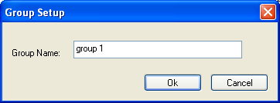

Figure (40)
『Matrix Control』 The product of our company supports connection to ADT matrix and MK matrix. Click this button, and the matrix control box as below will pop up
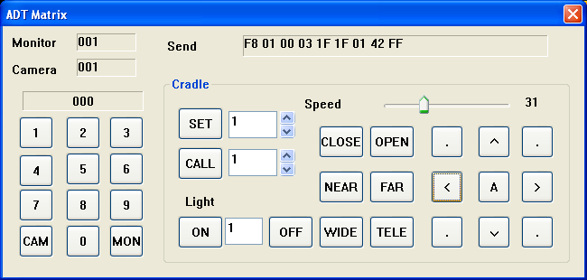

Figure (41)
『Cradle Head Cruise』Click this item, and the cradle head cruise setup box as below will pop up.
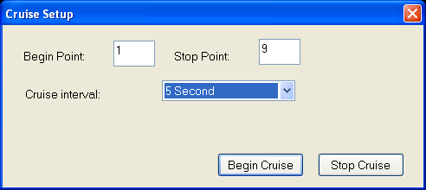

Figure (42)
Steps for Cruise Setup
Note: It is necessary to firstly set the preset points before cruise settings, and the preset points must be sequential.
『Begin Point』: Input the beginning preset position.
『Stop Point』: Input the stop preset position (the total number of preset positions will be added by 1).
『Cruise Interval』: In the drop-down list, select the cruise interval.
After the settings are finished, please click『Begin Cruise』.
When you want to stop the cruise operation, please click『Stop Cruise』.

Chapter VI Common Problems in Center Management Software

6.1 Unable to access the network surveillance device via the center management software
Possible Cause: Network is not connected?
Solution: Connect the computer to the network to test whether the network connection is normal. Firstly troubleshoot the cable failure, network failure caused by the computer virus and firewall block, until the computers can Ping each other.
Possible Cause: IP address is occupied by other device?
Solution: Disconnect the network surveillance device and the network, and then only connect the network surveillance device to the computer, and then reset IP address according to the correct operation.
Possible Cause: The IP address of computer and that of the network devices are located in different network segment or subnets?
Solution: Check the settings of IP address, subnet mask and gateway of the server.
Possible Cause: unknown?
Solution: Use the preset button of server to return to the factory defaults, and then reconnect. The default IP address for the DVS/IP Camera system is 192.168.1.100, and the subnet mask 255.255.255.0.

6.2 Abnormal image color
Possible Cause: the light on the spot is too bad.
Solution: Check the light on the spot is normal and add auxiliary light source.
Possible Cause: The video system is not set correctly?
Solution: Check whether the video system (PAL or NTSC) is set correctly.
Possible Cause: the Brightness/Contrast parameters are not set correctly?
Solution: Adjust the Bright/Contrast parameters according the actual situation on the spot.

6.3 Cradle head and lens out of control
Possible Cause: The signal cable is not connected well or connected incorrectly?
Solution: Reconnect the control cable between the cradle head or dome camera and the server.
Possible Cause: Fail to correctly set the corresponding encoder protocol, address or baud rate?
Solution: Please carefully check whether the setting is correct.
Possible Cause: The control cable is too long?
Solution: Thicken the control cable.
Possible Cause: The device power is not enough?
Solution: use the standard power adapter and enlarge the device power.

6.4 No sound when listening
Possible Cause: Have no audio input device connected.
Solution: Check the audio connection of host.
Possible Cause: The audio option of front-end device is not opened?
Solution: Check the audio parameters settings of front-end device to confirm whether the audio is opened.

6.5 Bad audio effect
Possible Cause: When there are many noisy sounds in the audio and the distortion is very serious, please check whether the input signal level is the line input. When the input signal is not line input most of time (for example, with a magnified active microphone), it will not match the input level of the server, which will cause saturation distortion.
Solution: Use the proper line input according the acceptable range of this video server.

Chapter VII Factors Influencing System Performance
When building the system, you must consider the performance of the entire system, the factors influencing your system, and the settings making your system in an optimized performance. Bandwidth is what you consider usually, i.e. how to set the bit rate. Other factors such as frame rate should be also considered. When the center management software has excessive connections, it will influence the frame rate of the server.
Hereunder we will introduce some common factors that we need to consider when building the system and will influence the efficiency of server:
- The network bandwidth is what you should consider firstly. There is normally no problem when you are in the local area network. But if you are in the wide area network and some exclusive network, you must consider the uploading bandwidth of the network. If the uploading bandwidth is relatively small, for example, the upper limit is 512k, you'd better not make the output bit stream of server more than 512k, otherwise the discontinuous audio or video will appear.
- ADSL is the second factor we need to emphasize. The bandwidth that we usually concern is the downlink bandwidth of ADSL, but what we use when we use the video server is the uplink bandwidth of ADSL. Therefore we must concern the uplink bandwidth of ADSL when we design the system. For example, for a general ADSL 2M, it has a downlink bandwidth of around 1.5M, but its uplink bandwidth is less than 512k. Therefore the uplink bandwidth is what we should concern more when we design the network.
- For details about how to set the image parameters according to the network, please refer to “Image Advanced Settings” of “Image Settings”.
- When there are excessive center management softwares viewing the image of a video server at the same time, it will influence the server performance and cause a decreased video frame rate. Therefore we recommend the number of channels that connected to the video server and the video is opened is not more than 19.
- The snapshot function provided by the video server is to snapshoot the picture at the front-end. Therefore frequent snapshoot will influence the server performance and cause a decreased video frame rate.
- The heavy network load will influence the system performance, and may bring discontinuous audio and video.
- The low CPU performance of the center management software will also bring discontinuous audio and video.

